**Introduction**

Our mission to Mars is about to start 🛸 but before we can take off we must resolve a mix-up.

Someone has mishandled the labeling of two Mars rover projects — Curiosity and Perseverance — we must classify them correctly.

[Click here](https://www.aicrowd.com/showcase/baseline-rover-classification-fb3fe8a2-69a8-499f-84c1-9e2003dcb053)to access the starter-kit and avert the emergency!



💾 **Dataset**

The given dataset contains images of two different rovers i.e. Curiosity and Perseverance of size 265*256 in jpgjpg format. The images in [train.zip](http://train.zip/) and [val.zip](http://val.zip/)  have their labels i.e. which rover it is in train.csv and val.csv. The labels for the images in [test.zip](http://test.zip/) needs to be predicted.

**📁 Files**

Following files are available in the resources section:

* [train.zip](http://train.zip/) - (40000 samples) This zip file contains rover images with images name corresponding to ImageID column of train.csv
* train.csv - (40000 samples) This csv file contains the ImageID column corresponding to [train.zip](http://train.zip/) and label column as the name of rover.
* [val.zip](http://val.zip/) - (4000 samples) This zip file contains rover images with images name corresponding to ImageID column of val.csv
* val.csv - (4000 samples) This csv file contains the ImageID column corresponding to [val.zip](http://val.zip/) and label column as the name of rover.
* [test.zip](http://test.zip/) - (10000 samples) This zip file contains rover images which will be used to evaluate the performance of the model.

**🚀 Submission**

* Prepare a CSV containing ImageID column corresponding to [test.zip](http://test.zip/) and label column as rover name.
* The name of the above file should be **submission.csv**.
* Sample submission format available at sample_submission.csv in the resources section.

**Make your first submission**[**here**](https://www.aicrowd.com/challenges/roverclassification/submissions/new)**!!**

**🖊 Evaluation Criteria**

During evaluation [F1 score](https://scikit-learn.org/stable/modules/generated/sklearn.metrics.f1_score.html) is used as Primary Score and [Accuracy Score](https://scikit-learn.org/stable/modules/generated/sklearn.metrics.accuracy_score.html) as Secondary Score will be used to test the efficiency of the model.

**🔗 Links**

* 💪 Challenge Page: <https://www.aicrowd.com/challenges/rover-classification>

**Solution**:

The problem is solved using resnet 18 using pytorch and trained in GPU for 16 epochs using adam optimizer and Cross entropy loss.

Epoch = 15/16, Val Acc: 99.78, Train Acc: 99.93

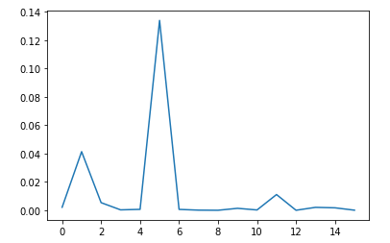

The leader board score is shown below (accuracy of 65.8%)

